KNN for Economics Science
Country growth clubs (from-scratch) + recession screen (sklearn) · short name KNN_Econ

Problem Statement
A new country or a new quarter arrives with a stack of indicators and no regime label. K-Nearest Neighbors asks which labeled peers sit closest in indicator space and what those peers voted. Two traps block a naive vote. (1) Units differ: 40-point inflation dwarfs a 4-point investment/GDP gap. (2) k is a bias–variance knob: k = 1 copies one crisis quarter; huge k copies the sample expansion rate. The project votes by hand on 40 countries, then scores 569 quarters × 16 CLI-style series (212 recessions / 357 expansions) while k, scaling, label noise, n, and junk series change.

Solution Strategy
Euclidean distance in n-D (Manhattan alternate). Min-max each column on the training fold only. Take the k nearest peers; majority wins (odd k avoids ties). Same pipeline via KNeighborsClassifier. Stratified 80/20, seed 100. Sweep k = 1…50. A Phillips-style inflation–Δu plane shows the jagged k = 1 vs smooth k = 21 boundary. A current-account table is extra practice. Simulation knobs: k, flipped recession dates, training fraction, padded noise series. Four audience rewrites in the memo.

Solution
Check | Result | Note
Korea vs Ireland (2-D) | d ≈ 7.52 | Closer than Argentina (π + I/Y)
Recession split | 455 / 114 | test_size=0.2, seed=100, stratified
k = 3 unscaled | 0.754 | Wide-range series dominate distance
k = 3 min-max scaled | 0.947 | Every indicator contributes fairly
Best scaled k | k = 3 → 0.947 | 114 hold-out quarters
+80 noise series | ~0.85 | Curse of dimensionality
Naive expansion floor | 0.627 | Always call the majority class
Validation accuracy vs k (scaled vs raw). Companion panel: knn_econ_simulation.png.
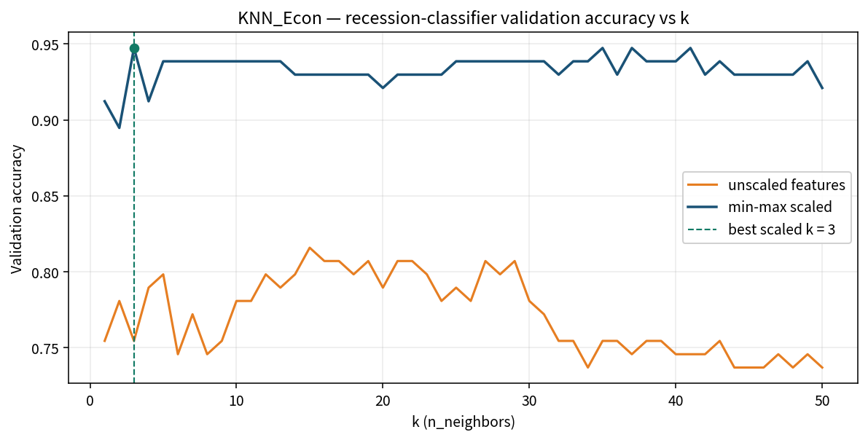

Key Takeaways
- Closeness is a distance over all indicators — not “the most important series.”
- Normalize first. Unscaled inflation or equity returns will own the peer list.
- Small k overfits one crisis; large k underfits toward the expansion base rate.
- Odd k removes 2–2 ties. sklearn.predict takes new quarters, not the training book.
- KNN is a nowcast screen, not a structural model and not the dating committee.
- Junk series make every quarter look equally far. Prune before you vote.

